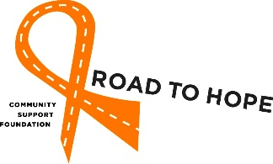
Volunteer Driver Application Form

Mission:
The Road to Hope Community Support Foundation is a group of dedicated volunteers committed to providing transportation and support to individuals undergoing medical treatments for cancer within the counties of Lac La Biche and Athabasca.
Quite often getting to and from cancer related medical treatment outside their home community can be a challenge. The Road to Hope Community Support Foundation can help. Road to Hope volunteer drivers provide transportation to and from medical treatment appointments and offer friendly support along the way.

By becoming a Road to Hope volunteer driver you will have a unique opportunity to put your special talents to work for the good of others.

To volunteer:

1. Call Road to Hope at 1-780-327-9442.
2. Complete the information below.
3. Sign and date the volunteer driver waiver section.
4. Provide and enclose a current driver's abstract (also called a driving record).
5. Provide and enclose a RCMP security clearance (also called a vulnerable sector check).
6. Provide proof of valid vehicle insurance.
7. Provide proof of valid Driver’s License.

Please forward your completed form(s) to: Road to Hope, P.O. Box 182, Athabasca, AB T9S 2A3
or roadtohope.ca@gmail.com

Volunteer Driver Information:
Name: (First, Last) | Email: (preferred)
Mailing Address: | Date of Birth:
Home Phone #: | Mobile #:
Emergency Contact Name: | Relation to Emergency Contact:
Emergency Contact Home Phone #: | Emergency Contact Mobile #:
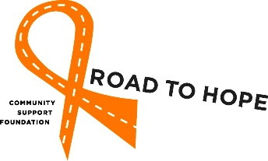Driver Screening and Insurance Requirements:

Please Initial:

[ ] |  | I have attached a Driver's Abstract.
[ ] |  | I have attached a photocopy of valid vehicle registration.
[ ] |  | I have attached a RCMP Vulnerable sector check.
[ ] |  | I have attached a photocopy of my vehicle insurance that shows the company name and policy number, as well as confirms a minimum automobile liability amount of Two Million Dollars.
[ ] |  | I have attached a copy of valid Driver’s License.
Please note vehicle information is required for EACH vehicle you may drive. Please provide Road to Hope with updated vehicle information.

Responsibilities of Road to Hope volunteer drivers:
• To be willing to drive to, and in, the city of Edmonton. Location of client medical treatments can vary
however over 90% of Road to Hope clients use the services of Cross Cancer Institute in Edmonton.
• To be willing to participate on one drive-along to familiarize yourself with the expectations of a
Road to Hope driver and to orientate yourself with the treatment centre area layout.
• To carry Road to Hope identification when transporting clients.
• To be willing to accompany client into their appointment, if requested.
• To operate your vehicle in compliance with all traffic laws and regulations.
• To keep your driver's license current.
• To abstain from smoking in the vehicle during transportation of the client.
• To abstain from the use of alcohol and/or drugs (prescription or otherwise) that may impair driving, before, during transportation and while waiting for the client.
• To keep all client information strictly confidential.
• To inform Road to Hope Transportation Personnel of changes in vehicle information.
• To inform Road to Hope Transportation Personnel, immediately, of any material changes to your
driver’s abstract or insurance coverage, as well as provide copies of the updated documents.

Preferred availability and unavailability (summer/winter/day/night): _______________________________________________________________________________________ ___________________________________________________________________________________________
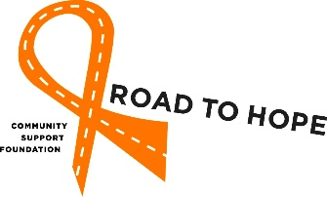
Road to Hope Volunteer Driver Waiver

As a Road to Hope Volunteer Driver I agree,

- To follow the responsibilities of the Road to Hope volunteer drivers listed above.

- I understand I cannot give medical advice including comments and suggestions that personalize medical information and or influence treatment decisions. If a client seeks information, I will direct them to the medical professional(s).

- I understand I am representing Road to Hope Community Support Foundation during my time volunteering and I will always act in a professional manner.

- I voluntarily and freely assume all risks of loss, damage, injury or death that I may sustain as a result of participation with Road to Hope Community Support Foundation and hereby release and discharge Road to Hope Community Support Foundation, its agents, employees, and directors from any claim or action that I may have with respect to my participation in any Road to Hope Community Support Foundation activities and or while volunteering for Road to Hope Community Support Foundation. This waiver is binding on me, my heirs, next of kin, executors, administrators and insurers.

By signing below, I acknowledge that the information provided is true and accurate and that I have read, understood, and will abide by this volunteer agreement, all points identified in volunteer driver waiver section above.

Volunteer Signature: _______________________ | RTH Personnel Signature: __________________________
Print Name: ______________________________ | Print Name: _____________________________________
Date: ___________________________________ | Date: __________________________________________
The personal information collected on this form will be used for the purpose of evaluating the eligibility of a volunteer driver applicant. If you have questions about the collection and use of this information, contact Road to Hope Community Support Foundation at 780-327-9442.

